Puppy Training Resource Pack

Animal Welfare and Dog Law
ANIMAL WELFARE
All pet owners within the UK have a legal duty to provide adequate care for their pet.
All pets have the legal right to:
- Live in a suitable environment
- Eat a suitable diet
- Exhibit normal behaviour patterns
- Be housed with, or apart from, other animals (If applicable)
- Be protected from pain, suffering, injury and disease
Failure to provide these rights to your pet may result in imprisonment (up to 6 months) and a fine of up to £20,000. You may also have your pet taken off you and be banned from having pets in the future.

DOG LAW
- Owners who allow their pets to hurt a person face punishment of up to 3 years in prison for injury or 14 years for death, an unlimited fine, disqualification from owning pets and having their dog destroyed.
- Even when no injury is caused, owners can still go to prison for up to 6 months; be fined up to £5000; be banned from owning pets and have their dog destroyed. A dog does not need to bite in order to be seen as “out of control”.

DOG LAW: DOGS AND LIVESTOCK
- Dogs should not be allowed to scare livestock. Dogs should be on lead when in an area that contains livestock. Your dog does not have to bite livestock to scare them. Dogs that chase, or bark at, livestock can actually cause animals to abort their young due to the stress.
- Farmers have the right to shoot your dog if they catch them bothering their livestock.
- If you live near livestock, then you must ensure that your home is secure to prevent your dog escaping and attacking livestock.

DOG LAW: DOG IDENTIFICATION
- As of April 2016, it is that law that all dogs must be microchipped, and the owner’s details must be correct and registered on an authorised database.
- Puppies must also be microchipped before they go to their new homes. Breeders should be registered as the first keeper and pass on correct paperwork to the new owner when the puppy goes home.
- All pet dogs must wear a collar with the owner’s name and address on it when in a public place.

DOG LAW: DOG FOULING
- Let’s all be honest: getting dog poop on your shoes isn’t just embarrassing, it also really stinks. On top of that, it also poses a hazard to humans and other animals.
- You must pick up your dog’s poop in most public places, however there is no legal requirement to pick up your dog’s poop in areas of heathland, woodland and on land used for grazing animals.
- Owners can be noticed with a fine of up to £100 for allowing their dog to foul public places.

Doggy Body Language
- Being able to read your puppy’s body language is important in preventing them from experiencing negative emotions. Preventing these negative emotions is also important in preventing behavioural problems from occurring.
- If your puppy learns that you will intervene and remove them from a negative situation then they will be a lot less likely to be fearful and then escalate their actions to a threat. I have included a few infographics below about dog body language so you can refer to it when needed.
- You should NEVER punish a puppy if they show uneasiness about a situation. This will only make matters worse. If they seem uncomfortable in any way you should always remove them from that situation and then work out why your puppy is unhappy. If your puppy begins to show serious signs of aggression or fearful behaviour then seek the help of a qualified behaviourist.

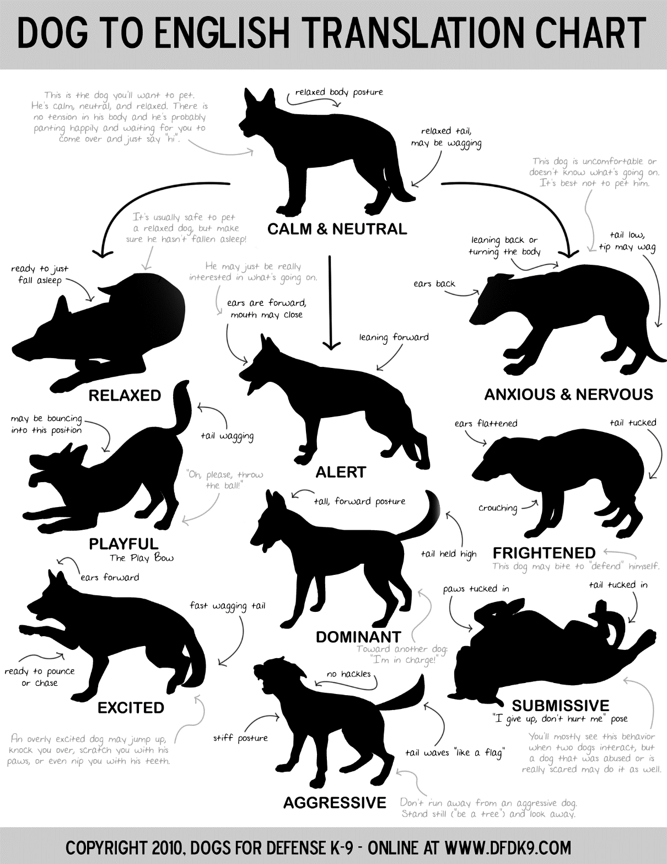
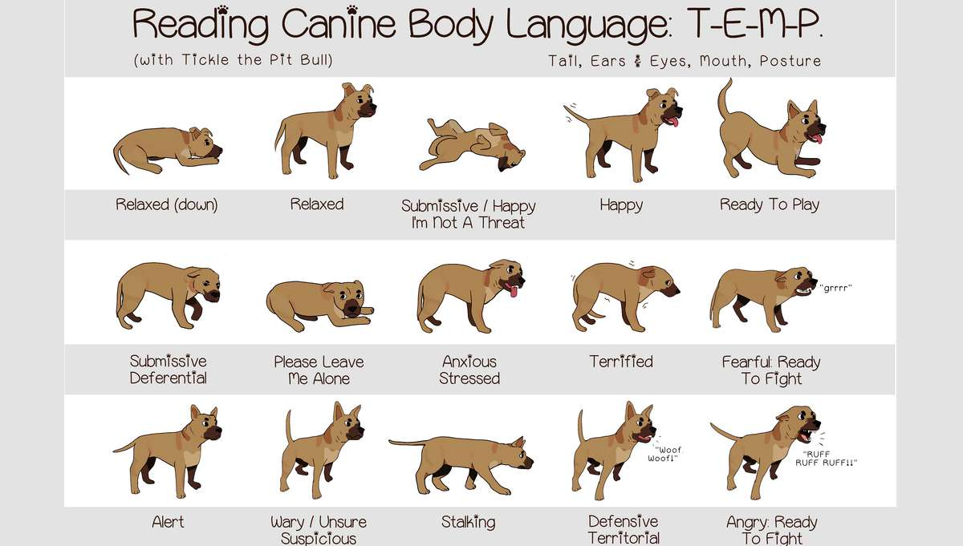

Confidence, Surprises and Handling
CONFIDENCE
- There are several things that your puppy might find scary, so we need to make sure we introduce these things properly.
- Introductions to new people, new things and other animals need to be done in a low-key way. Remember: Socialisation is always quality over quantity.
- When introducing your puppy to other dogs, make sure the interaction is managed in a way that your puppy doesn’t feel overwhelmed. This is especially important for smaller breeds who may be particularly frightened if a dog comes bounding up to them, friendly or not.
- Try to avoid letting children run over to your puppy in an excited manner as this can overwhelm them and make them fearful of children in the future. Again, this is especially important for smaller breeds.
- Make sure that these experiences are always positive. Pay attention to your puppy’s body language.
- You should introduce your puppy to a range of experiences and people within the first 4 months to help your puppy get used to them and prevent fearful reactions. Things you might want to introduce to your puppy include:
- Bicycles
- Joggers
- People wearing hats/sunglasses
- Rubbish bags
- Hoover
- Broom
- Hair dryer
- Washing Machine/Tumble dryer

- When introducing these things to your puppy, it should be done gradually and in steps. You should also avoid over exposing your puppy to too many things at once. Take it slow.
SURPRISES
- Puppies need to learn how to appropriately deal with things that might surprise them, such as loud noises or things waving in the wind.
- There are things you can do to help teach your puppy that surprises aren’t a bad thing, and that they can actually be a good thing.
- When your puppy is sleeping, go over to them and gently wake them up and then immediately give them a high value reward. This exercise should not be done often as it’s not good to wake a sleeping puppy since they do most of their growing in their sleep.
- When your puppy is engrossed in playing with a toy or chewing on a bone, suddenly walk up to them and then give them something they really like. This should help your puppy get more comfortable with people approaching him suddenly.
- Without scaring your puppy, you should make a loud noise a moderate distance away (dropping your keys or clashing a pan lid) and then immediately drop a high value reward. Again, this exercise should be done with care and not very often. You want to ensure you don’t scare your puppy too much and that you just startle them.
HANDLING
- Puppies need to learn to tolerate handling by their owners as well as strangers.
- To help your puppy learn to enjoy being handled, gently touch him and then feed him a treat.
- Continue doing this from the head from the tail, paying particular attention with the paws and the ears as these are the areas that puppies dislike being touched most.

Impulse Control and Calmness
IMPULSE CONTROL
- Puppies need to learn how to toleration frustration and show self-control. Puppies that grow into dogs that are impulsive and easily frustrated are not easy to live with and can even show aggressive behaviours as a result of the frustration.
- Teaching sit, leave and drop to your puppy can be crucial day-to-day cues that you can use in every day life with your puppy. These cues also help to teach your puppy self-control.
Teaching sit:
- With the treat in your hand, push it past your puppy’s nose. Their nose should follow the movement of the treat and this should encourage their bottom to hit the floor.
- When this happens give them the treat and mark the correct behaviour with a word like “Yes!”
- Only when your puppy is reliably doing the behaviour correctly i.e. putting his butt on the floor, should you then add the word “Sit”.
Teaching leave:
- Put a treat in your hand and hold it in a fist, present your hand with the treat inside to your puppy and begin to slowly open your hand.
- If your puppy moves towards your hand, immediately close your hand back into a fist and move it away from them (I normally bring my hand to my chest).
- Keep doing this until your puppy does not move towards your hand when you present it to them.
- Once you can open your hand without your puppy moving towards it, wait only 1 second to begin with, and then give them a release cue e.g. “Ok!” or “Go!” to let them have it.
- When your puppy is reliably leaving the treat alone, you can start adding the cue “leave” when you present your hand.
- To increase the difficulty, make your puppy wait longer before you give them their release cue. Don’t increase the time too quickly though – remember you want your puppy to succeed!
Teaching drop:
- Pick up a toy and play with your puppy. Make sure you have treats or another toy at the ready.
- When your puppy is really into the game, present the other toy or a treat so they release the toy.
- When they are reliably releasing the toy, you can then start adding the word “Drop”.

CALMNESS
- Teaching your puppy how to relax and amuse themselves can be important as you may not always be able to give them your attention. Nor should you have to.
Teaching settle:
- Place your puppy’s bed next to where you normally settle in the evening and encourage them to lie down on their bed. If they don’t know lie down or they seem hesitant to lie down, just encourage them to their bed and start dropping treats on their bed.
- Do this every 10 seconds or so to begin with, to encourage them to stay on their bed. After a while your puppy should lie down, if they didn’t to begin with.
- Continue dropping treats and use the word “settle” while doing so to begin to associate that word with the action of staying on their bed.
- When you notice that your puppy begins to relax, use the word “settle” again to encourage that calm state of mind and reward them.
- You can also encourage your puppy to calm down and break away during the middle of a game by using the word “Enough!” and then scattering some treats. When he is done eating the treats or playing with the toy, you can use another word like “Let’s play!” to tell your puppy you’re ready to play again.

Listening and Following Rules
- Before expecting your puppy to follow your rules, you should set aside some time where you think about the rules you want to enforce with your puppy.
- Remember that your puppy doesn’t come with preloaded manners or understandings of how your house works. These rules will need to be communicated clearly to your puppy through appropriate training. These house rules should also be followed by everyone in the home.
- There is nothing wrong with allowing your puppy on the furniture if there are clear rules around it i.e. invite only or your puppy getting off the sofa when told.
- Sometimes management is key. For example: If your puppy doesn’t learn that chewing on your shoes helps with his teething pain then he won’t ever do it, so keep your shoes out of your puppy’s reach and provide him with appropriate things to chew on. Think about how you can set things up so that your puppy is less likely to do behaviours that you don’t want.
- The cues sit, leave and drop can be helpful in developing house rules and communicating clearly to your puppy what you want from them. Teaching these behaviours is outlined in the section “Impulse Control”.
- Remember to encourage behaviours you do want by rewarding your puppy and to discourage behaviours by ignoring your puppy or showing them what else they could do instead.
Manners and Making The Right Choices
- Making your puppy wait patiently for things, such as his food or a nice bone, can be an important tool in teaching them manners. Asking your puppy to sit before you give them something they want; take them out for a walk or before you open the front door can help in teaching them self-control. Once your puppy gets good at this, you can start to wait until they sit without you asking. This will help teach them appropriate manners naturally, rather than you having to ask every time. Be patient, it’s better to wait until your puppy makes the decision themselves.
- Allowing your puppy to run over to another dog is extremely irresponsible and dangerous. Especially as you have no idea how the other dog will react. Teaching a good, reliable recall and rewarding handsomely for when your puppy does come back to you will help your puppy in making the right choices when out and about.
- Again, using your sit, leave, drop and settle cues can be helpful to communicate to your puppy what you want. Teaching these cues is outlined in the “Impulse Control” section. Just use whichever one might be appropriate for the situation i.e. to prevent begging when you’re eating your dinner, you could give your puppy a food toy and use the “settle” cue.
Loose Lead Walking
- Teaching your puppy to walk calmly on lead is a difficult skill, but totally worth it. Lead pulling can result in pent up energy building in your puppy which can contribute to several behavioural problems.
- To teach loose lead walking you should first decide on which side you would like your puppy to walk on. Then you want to make sure you have very high value rewards (such as cheese or meat) cut into very small pieces.
- To begin with, you want to work in a safe and distraction-free environment. Your living room or another suitable room in the house would be appropriate.
- Attach your puppy’s lead and then, while saying nothing, wait until your puppy pays you attention. As soon as they do, reward them.
- Using another treat, lure your puppy to your chosen side and then feed your puppy a couple more treats for staying at your side.
- Take a step forward, and if your puppy moves with you, reward them. If your puppy doesn’t move with you, then use a treat to encourage them forward back to your side again.
- If your puppy pulls ahead of you, immediately stop and then wait for your puppy’s attention to come back to you. Once it does, reward them and then use another treat to bring him back to your side. Wait a little while so your puppy doesn’t develop the habit of yo-yo’ing backwards and forwards to progress.
- Continue doing this, rewarding every one or two steps, until you can walk 30 paces with your puppy remaining at your side.
- Once your puppy is reliably walking at your side, start to phase out the treats as the action of moving forward will begin to act as the reward once he’s reliably walking nicely on lead.

SOCIAL MEDIA AND MY BOOK
Follow me on Instagram @playertwodogtraining and tag me in your training videos!

I also have a YouTube channel where I documented some of Honey’s upbringing, along with all sorts of dog training information and advice, click here to go to the channel!

Did you know that I have written a book on managing common puppy problems?
You can get the kindle book on Amazon by clicking here “Quick Fixes to the Top Five Puppy Problems” for £4.99
